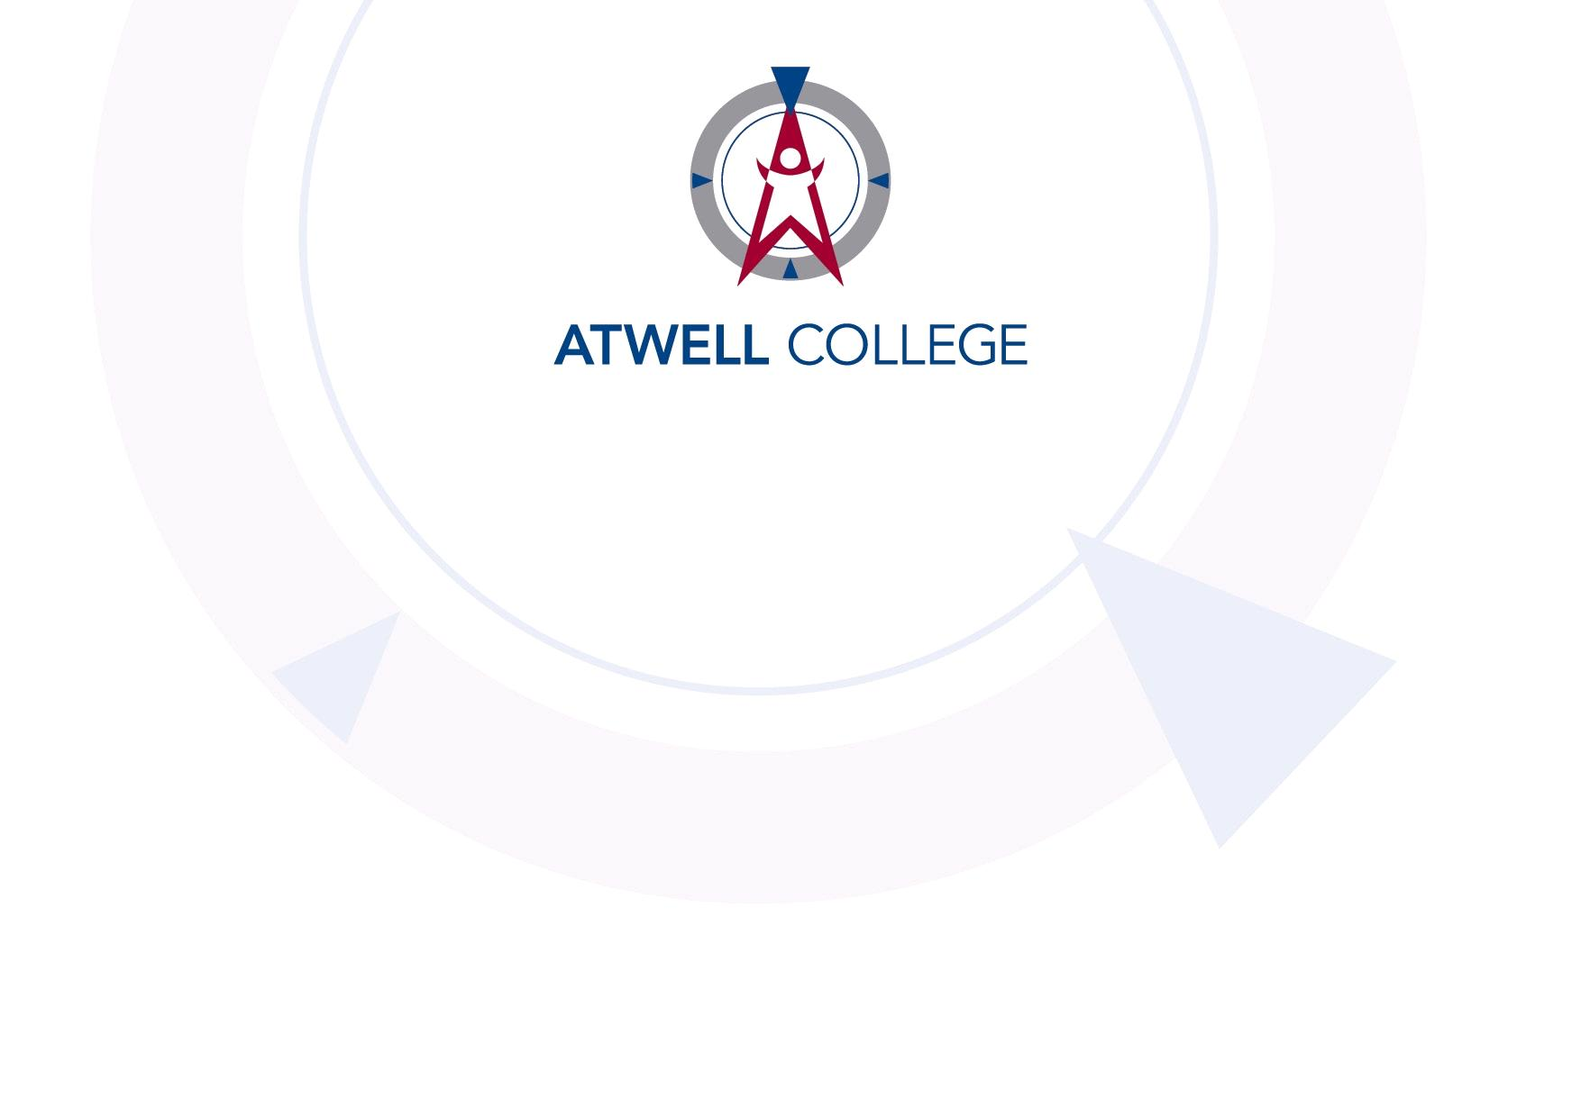

**Human Biology Year 12 – Task 4**

**Investigation Assessment**

**Background:** As a health researcher, you are applying for a National Health and Medical Research Council (NHMRC) grant, to fund an investigation into the efficacy of a new form of insulin called Hoy-Lamb3.2. You are optimistic that this artificially produced form of insulin requires far less frequent injection (only once per week) and produces fewer side effects than other forms. As such, you have decided to use a ‘gold standard’, double blinded randomised control trial. However, NHMRC funding is provided only once per year and is highly competitive: less than 5% of applicants are successful.

**Your Task:** You must write a research proposal to obtain this competitive funding grant.

Develop and outline your experimental design, so that you can ethically and efficiently investigate Hoy-Lamb3.2’s effectiveness in treating diabetes.

Please follow the template that follows in order to fulfil these requirements.

**Research proposal**

Title: (1 mark)

Aim: (1 mark)

Hypothesis: (2 marks)

Variables: (3 marks)

Rationale:

Referring to diabetes, explain why this research important to Australian society. (3 marks)

Explain, referring to endocrine function, how insulin is used in the body. (4 marks)

Explain how Hoy-Lamb3.2 would assist people diagnosed with diabetes. (2 marks)

Justify your choice of a double-blinded, randomised control trial. (2 marks)

Participants:

Who would participate in the research and how would you recruit them? (2 marks)

Method: (5 marks)

Safety and ethics: (6 marks)